Name: Reshma Akter

Batch:Database 2

**Assignment**

**No.1**

You have to develop a Human Resource Management database for a company. It requires that you have to add some information of departments, employees and projects including company. As mentioned, that every department has many employees and each employee work for a department and each department is leading by only one manager who is also an employee. Initially a new department need not have any employee. Here, though an employee belongs a department but they can work for different projects at the same time. Each employee can work for different job position like Developer, Programmer and front-end designer.

**Steps of Drawing ERD**

1. Identify the Entities Required;

2. Identify the Attributes and Primary key for each Entity;

3. Identify the Relationship needed;

4. Identify the Cardinality Ratio and Participation;

5. Draw the Diagram.

**Step 1: Identify the Entities Required**

You have to develop a Human Resource Management database for a company. It requires that you have to add some information of departments, employees and projects including company. As mentioned, that every department has many employees and each employee work for a department and each department is leading by only one manager who is also an employee. Initially a new department need not have any employee. Here, though an employee belongs a department but they can work for different projects at the same time. Each employee can work for different job position like Developer, Programmer and front-end designer.

**Step 2: Identify the Attributes and Primary key for each Entity**

* **Company** (Id, company_name, location, founded_date, Managing_director)
* **Departments** (Department_id, name, number_of_employee, manager_id, employee_id, company_id)
* **Employees** (id, first_name, middle_name, last_name, joining_date, email, phone, date_of_birth, gender, designation, salary, department_id, job_title)
* **Address (**Id, employee_id, Village_name, post_office, post_code, Upazila, District)
* **Phone** (Id, number, code, employee_id, sim_operator)
* **Job Position (**position_id, position_name, employee_id, name_of_employee, name_of_department)
* **Projects** (Project_id, name, number_of_employee, start_date, end_date, budget, company_id, description).

**Step 3: Identify the Relationship needed**

1. Employees work_for Department

2. Employee Manages Department

3. Employees work_on Project

4. Department Controls Project

5. Manager leading department

**Step 4: Identify the Cardinality Ratio and Participation**

1.**Company to Department:** One-to-Many

**Participation**: Total for Department

Controling

Company

Department

2.**Employee to department:** many to one

total for Employee

Partial for Department

Work_for

Employee

Department

3.**Department to project:** One-to-Many

controls

Project

Department

4.**Employee to Project:** Many-to-Many

Total for both Employee and Project

Work_on

Project

Employee

5**.Employee to Job Position:** One-to-One

Total for Job Position

Work_on

Job Position

Employee

**6.Manager leads Department:** one to one

leads

Department

Manager

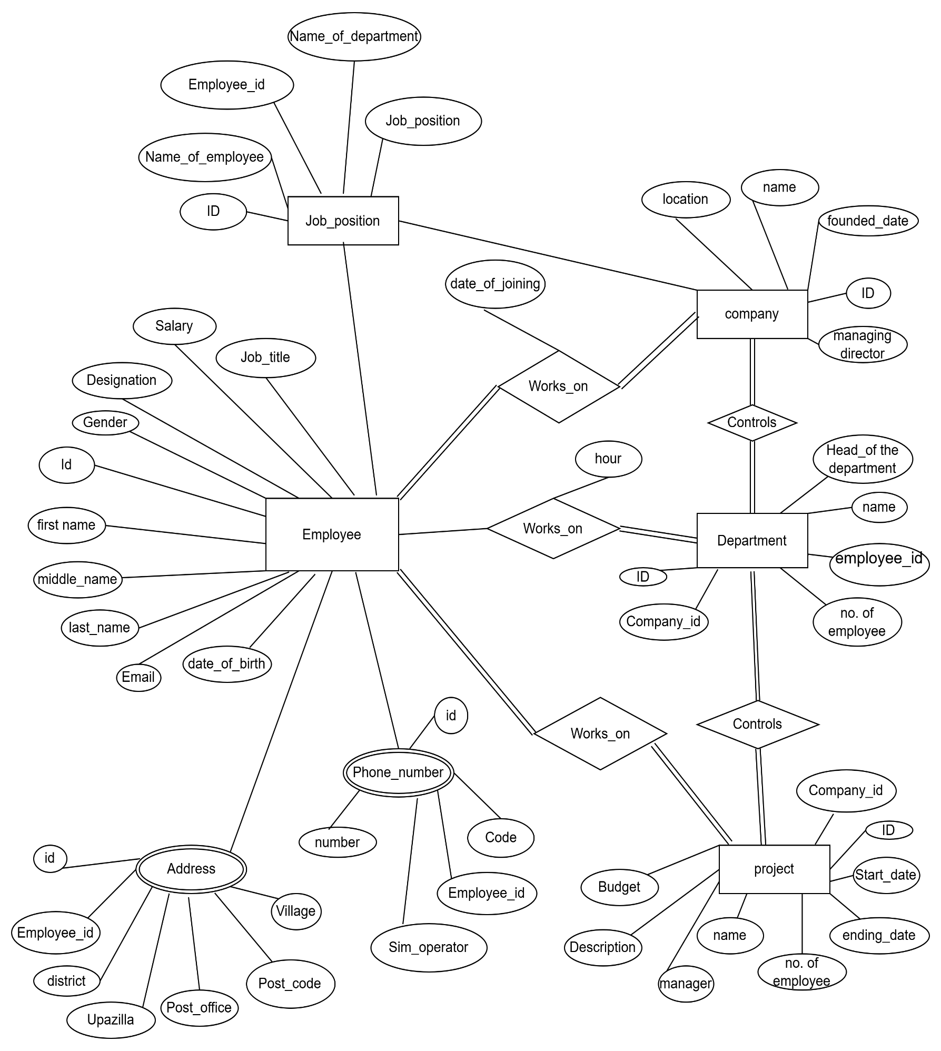

**Step 5: ERD Diagram**

**NO.2**

ER diagram for university management system

**Step 1: Identify the Entities Required**

Creating a university management system (UMS) database involves setting up tables for various entities like students, courses, faculty, departments, classes, and Enrollment.

**Step 2: Identify the Attributes and Primary key for each Entity**

* **Student (**Student_id (Primary Key), First_name, Last_name, Date_of_birth, Gender, Phone_number, Email, Department_id (Foreign Key references Department), Enrollment_date).
* **Department** (Department_id (Primary Key), Department_name, Head_of_department (Foreign Key references Faculty)).
* **Course** (Course_id (Primary Key), Course_name, Credits, Department_id (Foreign Key references Department), Course_description).
* **Faculty** (Faculty_id (Primary Key), First_name, Last_name, Email, Phone_number, Department_id (Foreign Key references Department), Joining_date).
* **Class** (Class_id (Primary Key), Faculty_id (Foreign Key references Faculty), Course-id (Foreign Key references Course), Semester, Year).
* **Enrollment** (Enrollment_id (Primary Key), Student_id (Foreign Key references Student), Class_id (Foreign Key references Class), Grade, Enrollment_date).

**Step 3: Identify the Relationship needed**

1.Student belongs to department

2.Faculty member belongs to department

3.Each course is offered by department

4.Faculty member teach Courses

5. Student can enroll in Courses

6.Class has multiple timetable slots.

**Step 4: Identify the Cardinality Ratio and Participation**

1. **Student - Department**: Many-to-One

Student

Belongs_to

Department

1. **Faculty - Department**: Many-to-One

department

belongs to

Faculty

1. **Course - Department**: Many-to-One

course

offered by

department

4.**Faculty - Class**: One-to-Many

Courses

teaches

Faculty

**5.Student** - Classes: Many-to-Many

Enroll

Student

Courses

**6.Class - Timetable**: One-to-Many

Slots

timetable

Class

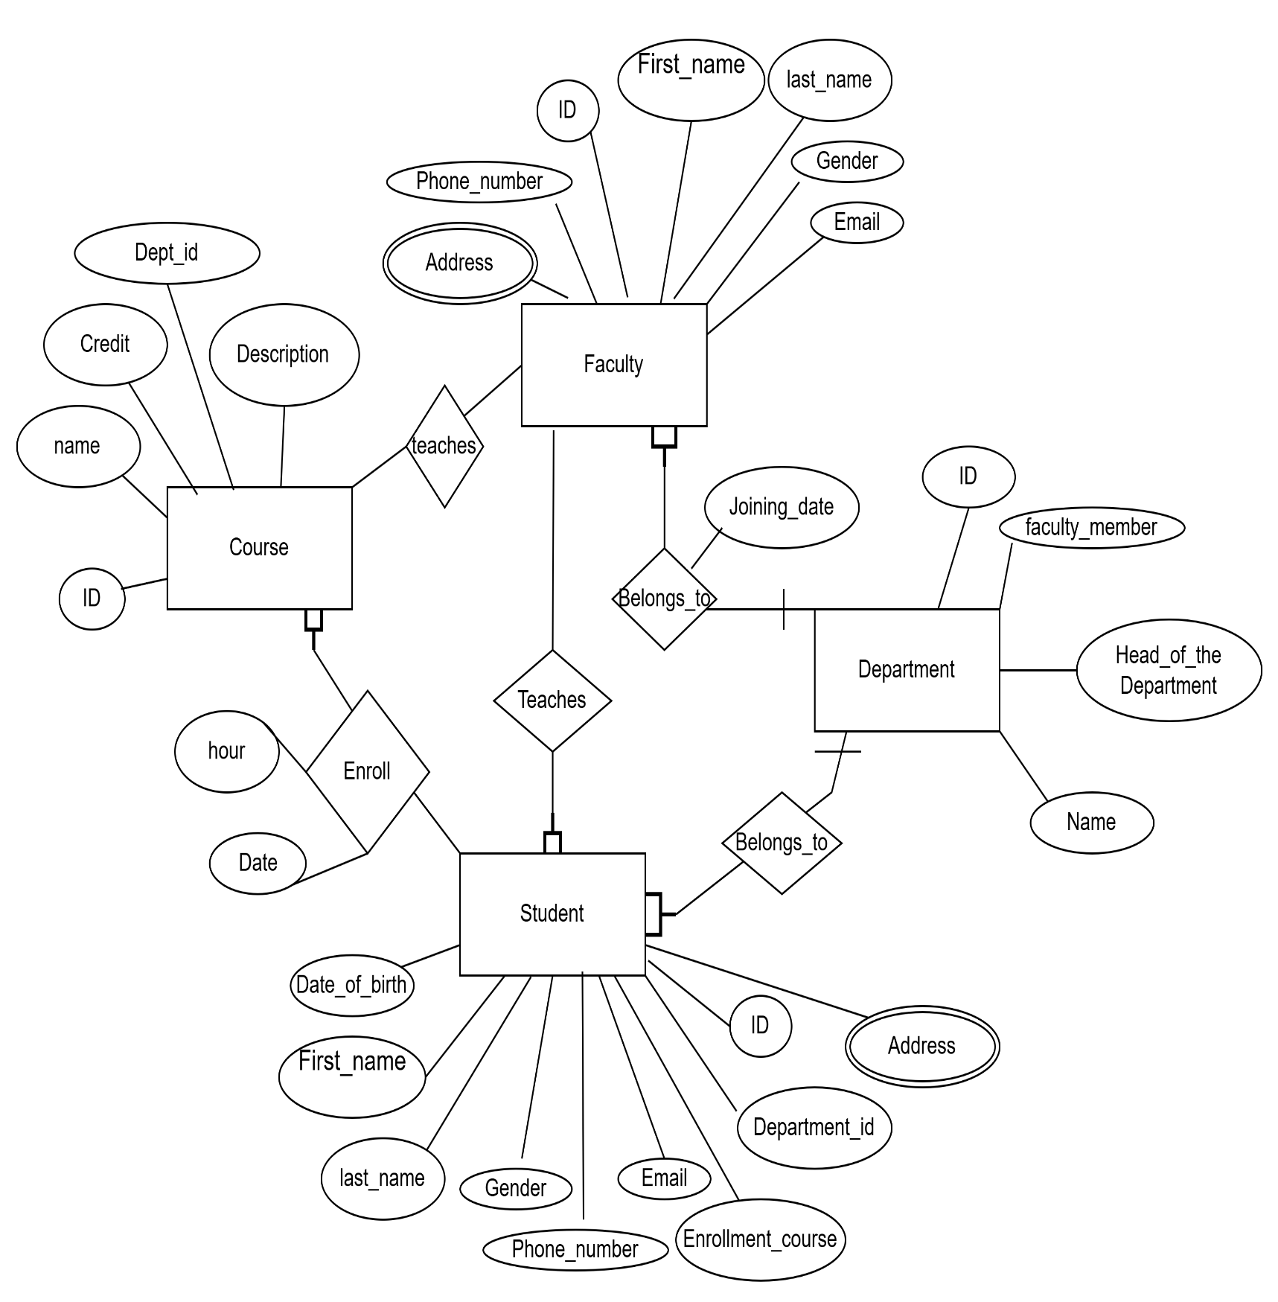

**Step 5: ERD Diagram**

**No.3**

Construct an E-R diagram for a car insurance company whose customers own one or more cars each. Each car has associated with it zero to any number of recorded accidents. Each insurance policy covers one or more cars, and has one or more premium payments associated with it. Each payment is for a particular period of time, and has an associated due date, and the date when the payment was received.

**Step 1: Identify the Entities Required**

* **Customer**: Customer_id (Primary Key), Name, Address, Phone_number, Email.
* **Car**: Car_ID (Primary Key), License_Plate, Make, Model, Year, CustomerID (Foreign Key to Customer)
* **Accident**: Accident_ID (Primary Key), Date, Location, Description, Car_ID (Foreign Key to Car)
* **Insurance_Policy**: Policy_ID (Primary Key), Policy_Number, Coverage_Details, CustomerID (Foreign Key to Customer)
* **Payment**: Payment_ID (Primary Key), Amount, Period, Due_Date, Payment_Date, Policy_ID (Foreign Key to Insurance_Policy)

**Step 3: Identify the Relationship needed**

1. Customer can own one or more cars
2. Each accident record is linked to car.
3. Each car can be covered by multiple policies
4. Insurance policy can have multiple premium payments
5. Each payment record is linked to a single policy.

**Step 4: Identify the Cardinality Ratio and Participation**

* Customer and Car (One-to-Many).
* Car and Accident (One-to-Many).
* Insurance_Policy and Car (Many-to-Many via Car_Policy).
* Insurance_Policy and Payment (One-to-Many).

**Step 5: ERD Diagram**

